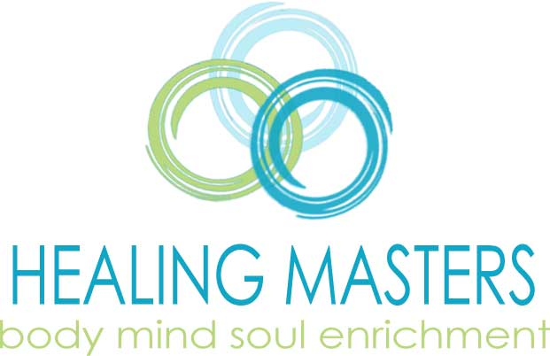 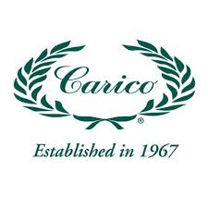

# **Fundraising & Giving Back**

**Earn Money for Your Organization with Healing Masters - Carico!**

Who wouldn't want to enjoy a relaxing massage, personalized health guidance, or life enrichment coaching? At Healing Masters, we provide all these services and more, helping people achieve their goals and improve their well-being.

**How It Works:**

* **Sell Gift Certificates:** Each gift certificate is worth $150, and for every one sold, your organization earns $30.
* **Easy Sales:** Sell to friends, family, and your community. Use our system for smooth transactions, including credit card processing.
* **Flexible Timeframes:** Choose to sell for one or two months—it's up to you!
* **Get Paid:** After the selling period ends, we'll cut your organization a check.

It’s that simple! Organizations have earned between $3,750 and $7,500 in just one month, and you can participate in this opportunity twice a year.

Located in Flower Mound, Texas, we serve clients from across the metroplex. Health and life coaching services are also available via Zoom, making it easy for anyone to participate.

So, skip the small profits from candy bars and restaurant fundraisers—make fast, significant cash with Healing Masters!

Visit our website at [HealingMasters.net](http://HealingMasters.net) for more details.

Questions? email [Mahealani@HealingMasters.net](mailto:Mahealani@HealingMasters.net) / text 469.215.0075